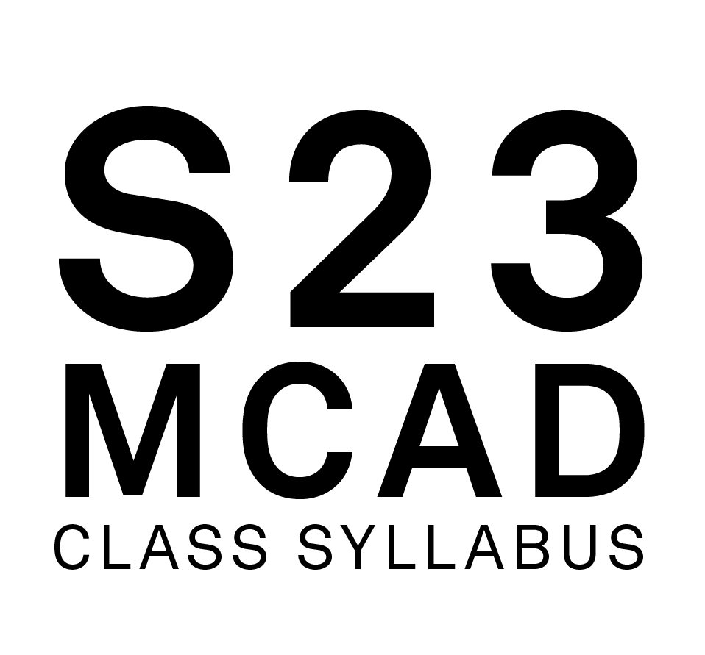

Course Name: Foundation: Media 1
Course Number: FDN 1311 02
Class Meets: R,
1:00 PM - 6:00 PM,
01/17/23 - 05/09/23
Class Google Meet Link: meet.google.com/zqk-ioim-yvd

Classroom: Main 414
Faculty Name: Severns, Benjamin
MCAD Email Address: ben_severns@mcad.edu
MCAD Telephone Number, Academic Affairs: 612-874-3694
Online Office Hours: Thursday - 1130-1230, Friday, 1130-1230
Office Google Meet Link: meet.google.com/abn-tpkr-bbd

FACULTY BIOGRAPHY:
Ben Severns is an interdisciplinary artist whose studio work is concerned with the spectacular. The media that his studio produces include filmmaking, photography, robotics, freelance writing, industrial music, software, and sculpture. In addition to having taught in both the Fine Arts and Media Arts departments at the Minneapolis College of Art and Design, Severns also holds an adjunct position at Augsburg University where he teaches courses in New Media and Web Design.
His work has been exhibited throughout the United States and internationally, including at Boston University, the Institute of Contemporary Art (Maine), the Science Museum of Minnesota, the Minneapolis Institute of Art, and Public Functionary Gallery. Pieces of his work are held in private collections in Australia, Brazil, and the United States. He currently performs as "BS" to industrial-noise nights at local/regional venues as well as operates as an autonomous member of the "Chaos Combat Marching Band" and "Death By Selfie" while he works on rebuilding his home/studio in North Minneapolis.

COURSE DESCRIPTION:
Students are introduced to digital resources at MCAD while exploring digital media. Areas covered include the Service Bureau, Gray Studio, and Media Center, along with other digital resources. Students use a variety of software and hardware to learn the basics of working with recorded media, including video, sound, and photography, as well as developing critical language for discussing media and media artists. Prerequisite: None

OUTCOMES:
Employ concepts and techniques in media art production and practice.
Articulate concepts and techniques through class critique.
Operate DSLR cameras for capturing still and moving images.
Edit still and moving images using professional photo and film software.
Record and edit sound digitally.
Employ basic lighting techniques for documenting artwork, and for media production.

METHODOLOGIES:
Lectures, Demonstrations, Discussions, Readings, Research/Analysis, Screenings, Class Exercises, Breakout Groups, Individual Projects, Group Projects, Case Studies, Writing Assignments, Written Proposals, Field Trips, Individual/Class Critiques

REQUIRED TEXTBOOKS. READINGS AND WEBSITES:
- none to add here : look on Canvas for links! -

LIBRARY RESERVE INFORMATION:
- none at this time -

MATERIALS AND TOOLS LIST:
MCAD-issued MacBook Pro
Digital still camera
Video camera
SD Memory cards for ^^^^
External digital storage device
*You can “double dip" and have a piece of equipment that does multiples of these things! We'll talk more about gear as it comes up this term - I take pride in being able to make do with what I can find/is available rather than exclusively needing the "finest" [$$$] equipment to own personally, and still returning excellent quality results. We will also be demoing with the Media Center’s substantial resources as assignments permit.

CANVAS:
https://mcad.instructure.com/courses/3529

MISCELLANEOUS:

COURSE CALENDAR:
Bullet list projects/assignments, project descriptions, and assignment due dates

CLASS_1 [1/19/23 ]
Expectations/Introductions/Syllabus
Media Center How-to/orientation
Definitions/Vocabulary

Unit 1: Stop-Motion
CLASS_2 [1/26/23]
equipment.mcad.edu
DSLR demo
Grey Studio demo
Unit 2: Photography
Photoshop demo 1 - Image adjustments, Layers, Modes

CLASS_3 [2/2/23]
Premier &&non-linear editing demo 1
Stop-Motion finishing touches
Photoshop demo 1.5 - Bridge, Camera Raw, File types, Color Space
1-1 meetings
CLASS_4 [2/9/23]
Unit 1: Stop-Motion critiques
Photography Unit [for part C] discussion - what’s the point of printing anymore?
Photoshop demo 2 - Advanced bulk processing, Actions, Automation
CLASS_5 [2/16/23]
placesandspaces.mcad.edu
Photoshop demo 3 - Getting ready to print
Service Bureau &&Epson inkjet print demo - this is how you complete 2C
Unit 3: Mix/ReMix/ReReMix
Audio Recorder equipment/technique demo
CLASS_6 [2/23/23]
Audition demo 1 - very briefly discussing what it is that we're doing here
PROJECT PLANNING - HOW DO YOU SCHEDULE LIFE/WORK/ART/SCHOOL AND STILL LIVE A LIFE THAT IS HAPPY AND SUCCESSFUL? (mind the daisies)
1-1 check-in meetings (there were so many demos)
CLASS_7 [3/2/23]
Audition demo 2 - effects, levels, pan, VSTs
Workshop time - Audition/mix strategies
Oblique Strategies workshop time
[photos] -text- [music] - what in the world are we writing about?
HotGlue.me Introduced - Unit 2, part 5
CLASS_8 [3/9/23]
Unit 3, part A: Mix [3:33] due for partner-trade to make ReMix [2:22]

Unit 5: Why Am I Here?
Unit 5, part A : WAIH Writing Begin
Storyboard demo - narrative arc, decision-making matrix
Studio workshop time - websites! Storyboards!
I’ve checked out the Gray Studio! Let’s document things!
[~~~midsemester break!!!~~~]
CLASS_9 [3/23/23]
Website troubleshooting - refresher re: images, resolution, colorspace, etc.
Storyboard Conversations
1-1 meetings
Unit 4: “Our Walk to the Walker” introduced
CLASS_10 [3/30/23]
Unit 2 critique - let’s talk about your website!
Writing and creative screen direction -> in-class exercise [look for notes on Canvas]
[~ Y T P ~]
CLASS_11 [4/6/23]
Field Trip to Walker Art Center [Our Walk to the Walker]
Unit 3, part B: ReMix [2:22] complete [small group convos]
CLASS_12 [4/13/23]
Premiere demo 1b [refresh & basics- edit/keyframe/effects]
Audition-Premiere demo
1-1 check ins
CLASS_13 [4/20/23]
Unit 3, part C: ReReMix [1:11] class critique
Workshop time
Premiere demo 2 [transitions, graphic elements, filters, layers]
Demo media installation - putting your video in the hallways is easier that you might think!
Premiere demo 3 [layers, COLOR, filters, easing]
CLASS_14 [4/27/23]
Unit 4: We Would Walk to the Walker! presentations
Video File finishing, export, compression, etc. demo
CLASS_15 [5/4/23]
Final Critique/Screening for Unit 5
So long, and thanks for all the fish.

EMAIL USAGE:
Email is used at MCAD as the official means of communicating with the student body. Official college announcements regarding policy, classes, registration, deadlines, etc. are delivered via email. Students are expected to check their MCAD email frequently and are held responsible for all official information communicated to them via the email system. Misuse or misrepresentation of official communications by students will result in disciplinary action.

ATTENDANCE POLICY:
In-Person, Online Synchronous and HyFlex
The MCAD community aims to foster engaged and meaningful learning experiences and a collaborative environment to promote academic success in all classrooms, whether Online, HyFlex or In-Person. MCAD is committed to creating a space of belonging and care so that students are supported and are able to participate fully in class. Full participation includes active engagement with course materials, the timely submission of assignments, and attendance at all class sessions.
Any absences, tardiness, or late assignments can result in the lowering of one's grade, at the discretion of the faculty. It is particularly important that students attend the first meeting of all courses whether Online, In-Person, or HyFlex; failing to attend the first class can impact your enrollment in the course and can have consequences on financial aid. Additionally, faculty can grant a seat to another student if a registered student has missed the first class session and has not communicated with the faculty to explain their absence.
For Synchronous Online and Hy-Flex courses, students should be prepared to utilize their computer’s camera and microphone functions and video platform chat feature to facilitate class engagement. Exceptions to this expectation may be arranged on an individual basis with the faculty.
In the case of extended illness or other documented circumstances that prevent a student from attending class, students must contact their faculty member who will work with them to determine whether missed classes or assignments can be made up and, if so, ways to satisfy the requirements of the class. Students are responsible for obtaining and reviewing any missed class materials. Faculty members are advised to communicate with their department chair or director if a student has extended absences. Faculty will not reteach a class a student has missed.

SPECIAL COVID-19 ATTENDANCE POLICY STATEMENT
If students are absent from class due to COVID-19 they must email their faculty and staysafestudent@mcad.edu. Documented absences due to COVID-19 can be excused and will not necessarily affect grades. Documentation could be a doctor's note, an official diagnosis from the issuing lab, or a photo of an at-home test emailed to staysafe@mcad.edu. Faculty will work with students to determine how to make up class time and assignments. Attendance will be taken for all In-person and HyFlex classes for COVID-19 contact tracing.

GRADING POLICY:
Grades consider student performance of assignments listed on each course syllabus, participation in class, magnitude of improvement, attendance, level of project difficulty, timeliness of project completion, compliance with class policies, and effort/dedication. + or - may be added to letter grades at the discretion of the faculty member. The MFA program employs a pass/fail grading system and does not use letter grades.

A = Excellent work, progress far beyond expectations of effort and outcomes, full participation
B = Good work, course requirements completed, preparedness for more advanced study
C = Average work, course requirements completed, preparedness for more advanced study
D = Passing but below average work, some promise of improvement
F = Work not acceptable, or course requirements not completed

GRADING PROCEDURE / CRITERIA:
Final grades will be based approximately 25% on participation and 75% on assignment outcomes. This means that if you're a technical all-star but don't contribute anything to class discussions critiques, etc., you'll end up with a C. To participate in class, you merely need to find a way to formulate an opinion, a question, or simply something that you yourself find interesting about one of the many skills and techniques we cover this term and then say it during our class meetings or continue the conversation from class with me over email.
That being said, submitted grades at midterm and end of term will be tabulated with regard to:
-Class attendance
-Engagement in process, assignments, and critique
-Commitment to task and conversation at hand, as well as its physical manifestation
-Rigorousness [radical] in relation to assignments, thinking, and conversation
-Magnitude of risk-taking, exploration, and improvement
-Class participation, initiative and effort
-Ability to meet deadlines
There are 5 units we will be discussing about this semester - they are all evaluated individually and will all factor into your final grade, but they will not constitute the only things affecting your grade at the end of term.
In order for your work to be “turned in” to be considered for grading, you must submit your digital files to the shared class Drive folder linked near the syllabus on the class Canvas page, according to the Archiving standards outlined in this document.

INCOMPLETE POLICY:
To receive a grade of Incomplete for a class a student must meet with the chair of the department or program director in which the class is taught to discuss the circumstances of the request.

GRADE NOTIFICATION:
Midterm grades will be posted on MyMCAD between weeks 7-10 of the semester. Final grades will be posted on MyMCAD the week following commencement.

ARCHIVING YOUR WORK:
Students are required to submit documentation of their work for each class, every semester. Please follow this naming convention: LastName_FirstName_ ProjectTitle.ext. Ex: oneill_co_DrawingA1.png

The media formats should follow MCAD archiving standards, which are found at:
http://kb.mcad.edu/index.php?category=64

Samples should be accompanied by a Word document containing relevant information, found at: http://kb.mcad.edu/index.php?article=166 - Text Listing

ACADEMIC DEFICIENCIES:
MCAD notifies students of deficiencies in academic performance through the student alert form at any time throughout the semester. Notices are placed in student mailboxes. Students are encouraged to contact the faculty member immediately and take steps to remedy the deficiency. If a student has two or more alerts the student will be contacted by the Dean of Student Affairs. A subsequent meeting will be scheduled to help the student analyze the problem and make realistic plans to remedy the situation and succeed in school.

CLASS RECORDINGS:
While the college does not require the recording of virtual classes, faculty may elect to do so for a variety of reasons that may include accommodating students in different time zones or for students to revisit the materials covered. In such cases, faculty must inform students at the beginning of each recorded session. Faculty who share the recordings with students will limit file permissions to view-only so as to respect the privacy of individual students. For

instructions on how to record in Google Meet, this brief video provides step-by-step instructions.

This information is taken from the Student Handbook. You are expected to adhere to college policy.

A. THE LEARNING CENTER:
The Learning Center provides interdisciplinary support for all MCAD students, including face-to-face and online tutoring, an online writing and learning lab (OWLL), small and large group workshops and in-class presentations, as well as academic accommodation services for students with disabilities. The Learning Center works with students to make them better learners and prioritizes equal access and opportunity for all students. Tutoring areas include writing, software and technical skills, time management, and study skills. For more information on the Learning Center’s Hours, instructions for how to make an appointment, and access to the MCAD OWLL, visit learningcenter.mcad.edu or call (612) 874-3671.

B. NONBINARY PRONOUNS/INSTITUTIONALLY RECOGNIZED NAMES:
MCAD strives to be an inclusive and welcoming environment for all students, alumni, faculty, and staff. Students may designate the use of an institutionally recognized name (previously referred to as alternate or preferred name) and pronouns. The forms for institutionally recognized names and pronouns are available on my.mcad.edu and are reviewed by Records Office staff upon submission. These forms also offer students the option of updating their email addresses via the Help Desk. Please note that the Records Office will reject any name submission that is offensive, inappropriate, misleading, or otherwise represents a use of the form in bad faith.

Institutionally recognized names and pronouns will appear on faculty rosters. Legal names will continue to be used as necessary in instances including, but not limited to, student accounts, responses to verification inquiries such as verification requests, financial aid documents, payroll, official transcripts, conduct and academic honesty records, and federal immigration documents.

Institutionally recognized names and pronouns are considered non-directory information under MCAD's FERPA policy.

Students wishing to update their records with legal name and/or gender changes will use a separate process and should contact the Records Office for more information.

C. LINKEDINLEARNING.COM:
Students can access a wide variety of online tutorials at Lynda.com using their MCAD login information: https://www.linkedin.com/learning/me?u=56747417

D. COURSE EVALUATIONS:
Course evaluations are an integral part of MCAD curriculum development. Student feedback on courses are instrumental in creating a vibrant, informed, and robust learning community at MCAD. For these, and many other reasons, students are encouraged at the end of the semester to provide extensive feedback on course evaluations.

E. CELL PHONE POLICY (optional):
Cell phones should be put on mute or vibrate during class. Calls can be made during breaks, as well as before or after class.

F. CREDIT HOUR DEFINITION:
In lecture/discussion courses requiring outside preparation, 1 hour of credit represents 50 minutes contact time each week in class, and 2 hours of work outside of class. Therefore, a 3-credit lecture course requires 2.5 hours in class per week and approximately 6 hours outside of class.

In studio/laboratory courses, 1 hour of credit requires a minimum of 1.5 hours contact hours each week in class and approximately 1.5 hours of work outside of class. Therefore, a 3-credit studio course represents a minimum of 4.5 contact hours in class and approximately 4.5 hours of work outside of class per week.

In online courses, 1 hour of credit requires approximately 3 hours of work per week for all activities (i.e., reading, viewing, making, scanning, responding to discussion threads, collaborating, etc.). Therefore, a 3-credit online course requires approximately 9 hours per week to complete the necessary activities.

G. CLASSROOM DEVICE USAGE POLICY:
Participation in a classroom community has many benefits, but students will also find that along with those benefits come responsibilities:
+ Students are responsible for bringing laptops to class when scheduled to do so.
+ Student laptops should be in good working condition. If a student is experiencing problems with a laptop, it is the student’s responsibility to go to the Help Desk for help: https://intranet.mcad.edu/department/help-desk. Technical difficulties such as problems printing, uploading, saving, or retrieving files do not excuse late or missing work.
+ During classroom discussion, demonstration, or lecture, students should not be connected to network resources unless students are specifically instructed to do so.
+ Chatting, using social media, or emailing is no more acceptable than talking on a cell phone during class time. Non-class related use of a laptop during class time, including working on homework for other courses, may result in restriction of laptop use or a grade penalty.
+ Unless otherwise indicated, students should never use headphones during class time.
+ Students should always store copies of files in two backup locations. Students should never store the only copy of a paper/project on the student server space in case the server is down, and students are unable to access the paper/project.
+ Recording by instructor permission only. See the MCAD Student Handbook for the full policy.

H. ACADEMIC INTEGRITY / SCHOLASTIC DISHONESTY:
Academic integrity is essential to a positive teaching and learning environment. All students enrolled in MCAD courses are expected to complete coursework responsibilities with fairness and honesty. Failure to do so by seeking unfair advantage over others or misrepresenting someone else’s work as your own can result in disciplinary action.

The MCAD Student Handbook defines academic dishonesty as follows:

Submission of false records of academic achievement; cheating on assignments or examinations; altering, forging or misusing a College academic record, document or funds; taking, acquiring or using test materials without faculty permission; acting alone or in cooperation with another to falsify records to obtain grades, honors, awards or professional endorsement in a dishonest manner; plagiarizing.

+ Plagiarizing: Quoting uncited materials, visual or written; presenting the work of others as your own; using work of other MCAD students without their express permission.
+ Using the Same Work in Different Courses: Students may not submit the same work for more than one class without the knowledge and consent of all faculty.
+ Consequences for plagiarizing and double submissions may include failing the assignment or the course, or academic probation.

Within this course, a student who is responsible for scholastic dishonesty can be assigned a penalty up to and including an “F” for the course. If students have any questions regarding the expectations for a specific assignment or exam, they should consult with their professor.

Using the Same Assignment in Different Courses: Studio projects are assigned and assessed according to the specific learning objectives for each course. Occasionally students may be assigned a project in one course that shares many of the learning objectives of an assignment given in a different course. While turning in the same assignment for two courses is not encouraged, students who wish to do so are required to first notify the faculty member of each course and get permission. Faculty may assign additional requirements. Failure to notify faculty can result in failure of the assignments in both courses.

I. ACCESSIBILITY AND EQUAL ACCESS:
Persons with disabilities have a right to equal opportunity as prescribed by law. MCAD is responsible for creating a barrier-free environment while empowering students to grow toward independence and self-assertion. It is the individual student’s responsibility to make their needs known and request accommodation. First-time disclosures must be made via appointment with the Learning Center or via our Disability Disclosure Form. For more information, visit learningcenter.mcad.edu or call (612) 874-3671.

